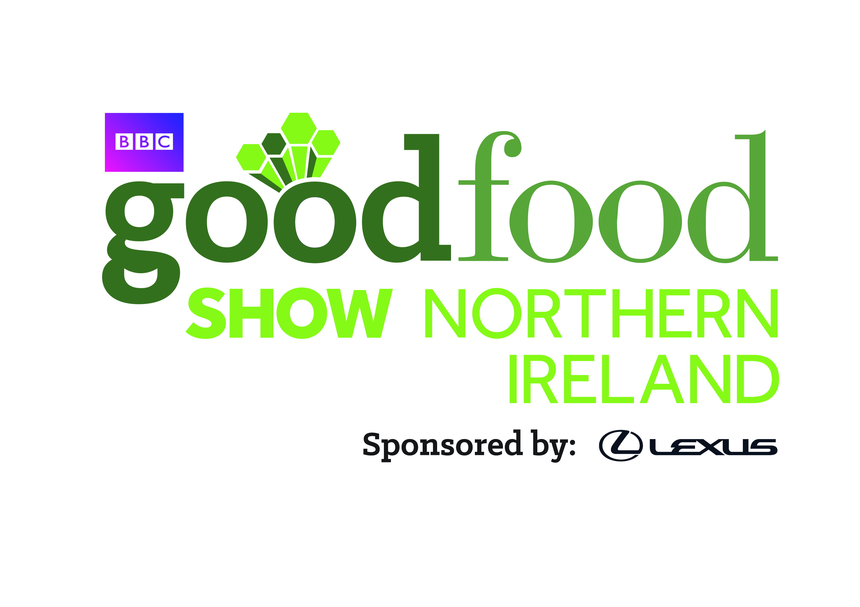 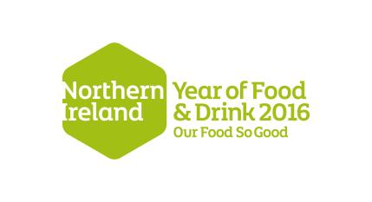

For Office Use

Date received:

Initials:

**Food NI BBC Good Food Show Booking Form**

|  |  |  |
| --- | --- | --- |
| **Company Details** | |  |
| Company Name |  |  |
| Contact Name |  |  |
| Email Address |  |  |
| Company Address |  |  |
| Telephone Number |  |  |
| Website |  |  |
| Twitter Name |  |  |
| Years Trading |  |  |

**Preferred Stand Number (or please write Gallery)**

|  |  |  |  |
| --- | --- | --- | --- |
| **Turnover - Please Tick** | | | |
| Less than £200K | £201K - £500K | £501K - £1m | £1m-£3m £3m - £5m |
|  |  |  |  |

|  |  |  |  |
| --- | --- | --- | --- |
| **Number of Employees (Including Yourself)** | | |  |
| Full Time | Part Time | Seasonal |  |
|  |  |  |  |

|  |  |  |  |
| --- | --- | --- | --- |
| **Distribution - Please Tick All That Apply** | | |  |
| Own Premises | Local Markets/Shows | Own Website |  |
|  |  |  |  |
| Farmshops/ Delis | Regional Supermarket | National Supermarket |  |
|  |  |  |  |

|  |  |  |  |
| --- | --- | --- | --- |
| **Type of Business - Please Tick** | | |  |
| Primary Producer | Secondary/ Processor | Supplier/ Retailer |  |
|  |  |  |  |

|  |  |  |  |
| --- | --- | --- | --- |
| **Awards and Membership - Please Tick/ Specify** | | |  |
| Regional Food Group | Great Taste Awards | Cheese Awards |  |
|  |  |  |  |
| Organic Certification | Irish Quality Food Awards | Blas na hEireann |  |
|  |  |  |  |
|  |  |  |  |
| Other – please specify |  | |  |

|  |  |  |  |
| --- | --- | --- | --- |
| **What are your main objectives at the BBC Good Food Show?** | | |  |
| Retailing | Market Research | Launch new product(s) |  |
|  |  |  |  |
| Sampling | Brand Awareness | Other (Please specify) |  |
|  |  |  |  |

|  |
| --- |
| **Product Range - Please Give Further Details** |
|  |
| **Please list other shows and events you have exhibited at** |
|  |
| **Please give some details on any other BBC Good Food Show(s) you are interested in and your proposed stand size (m²?)** |
|  |

**Food NI member Stand Costs – payable to Food NI Limited**

Hall 2 - Shell scheme 2m x 2m stand £480+VAT (RSE List price = £880+VAT)

Hall 2 - Shell scheme 3m x 3m stand £600+VAT (RSE List price = £1980+VAT)

Gallery Market Style - (no shell scheme 2m x 2m) £300+VAT (Set up style to be confirmed)

Electric and Lighting costs will follow.

All exhibitors will also pay £150+VAT Insurance Cover, unless they can include documentation with their application to show full exhibition cover, with public and employers liability. When we send your details to River Street Events, they will automatically raise an invoice for £150+VAT to you for exhibition insurance. However, on receipt of appropriate documentation, this invoice will be cancelled.

**50% required at the time of booking to secure your stand.**

**Please enclose payment with your Booking Form.**

**The final 50% is due by 31st August 2016 please.**

**Note**: Only the goods or services specified above may be promoted or sold from the stand when agreed by Food NI. Stand space cannot be sub-let, or given to another company.

*By signing this form, I understand the above, and that a 50% non-refundable deposit must be sent to Food NI with this completed booking form in order to secure a stand at the BBC Good Food Show. Stands are limited and confirmation of your preferred stand will be given within 5 working days. BACS details available on request. Please post cheques to Food NI Limited, Belfast Mills, 71-75 Percy Street, Belfast, BT13 2HW. I understand that the final 50% is required by 31st August 2016*.

**Signature:**

**Position:**

**Date:**

**Name (print):**

**Phone:**

**Email:**